Nama : Adridinan Najmi Faza
NIM : H1D025059
Shift Awal/Akhir : B/H
Responsi 2

- Membuat Database Musik show
MariaDB [(none)]> create database musikshow;
Query OK, 1 row affected (0.011 sec)

MariaDB [(none)]> use musikshow;
Database changed
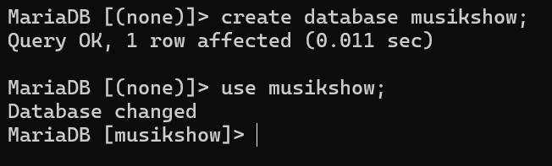

- Buat Tabel
MariaDB [musikshow]> CREATE TABLE Penonton (
-> id_Penonton char(3) PRIMARY KEY,
-> nama_penonton VARCHAR(100) NOT NULL,
-> no_telefon int(50)
-> );
Query OK, 0 rows affected (0.021 sec)

MariaDB [musikshow]> CREATE TABLE Tiket (
-> id_Tiket char(3) PRIMARY KEY,
-> jenis_Tiket VARCHAR(100) NOT NULL,
-> harga int(10)
-> );
Query OK, 0 rows affected (0.009 sec)

MariaDB [musikshow]> CREATE TABLE Pembelian (
-> id_pembelian varchar(3) PRIMARY KEY,
-> id_Penonton char(3) NOT NULL,
-> id_Tiket char(3) NOT NULL,
-> jumlah_tiket int (5),
-> total_harga int(10),
-> FOREIGN KEY (id_Penonton) REFERENCES Penonton(id_Penonton),
-> FOREIGN KEY (id_Tiket) REFERENCES Tiket(id_Tiket)
-> );
Query OK, 0 rows affected (0.022 sec)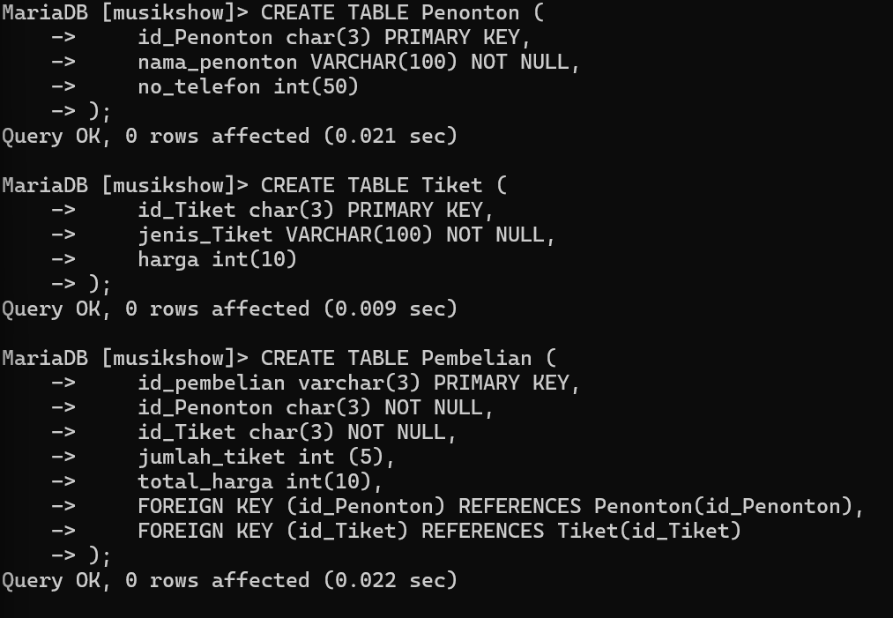

- Insert Values
MariaDB [musikshow]> INSERT INTO Penonton (id_Penonton, nama_penonton, no_telefon) VALUES
-> ('PN1', 'Aufa Algifari', 085947647645),
-> ('PN2', 'Almira Azaria', 081234566899),
-> ('PN3', 'Dhini Aqiila', 087654321234);
Query OK, 3 rows affected, 3 warnings (0.013 sec)
Records: 3 Duplicates: 0 Warnings: 3

MariaDB [musikshow]> INSERT INTO Tiket (id_tiket, jenis_tiket, harga) VALUES
-> ('TK1', 'Festival', 250000),
-> ('TK2', 'Premium', 500000),
-> ('TK3', 'VIP', 1000000);
Query OK, 3 rows affected (0.012 sec)
Records: 3 Duplicates: 0 Warnings: 0

MariaDB [musikshow]> INSERT INTO Pembelian (id_pembelian, id_penonton, id_tiket, jumlah_tiket, total_harga) VALUES
-> ('PM1', 'PN1', 'TK2', 10, 5000000),
-> ('PM2', 'PN2', 'TK3', 20, 20000000),
-> ('PM3', 'PN3', 'TK1', 15, 3750000);
Query OK, 3 rows affected (0.013 sec)
Records: 3 Duplicates: 0 Warnings: 0
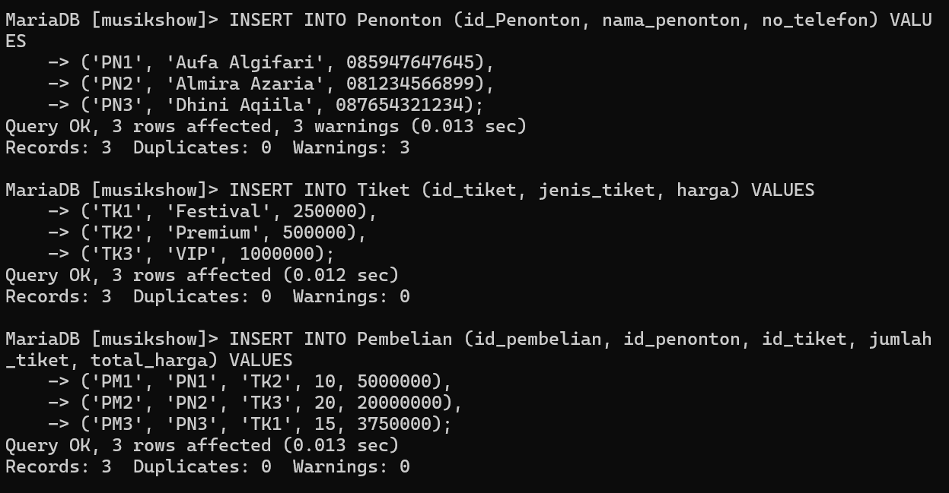

- Create Table History Pembelian
MariaDB [musikshow]> CREATE TABLE history_pembelian (
-> id_pembelian varchar(3) NOT NULL,
-> id_Penonton char(3) NOT NULL,
-> id_Tiket char(3) NOT NULL,
-> jumlah_tiket int (5),
-> total_harga int(10)
-> );
Query OK, 0 rows affected (0.018 sec)
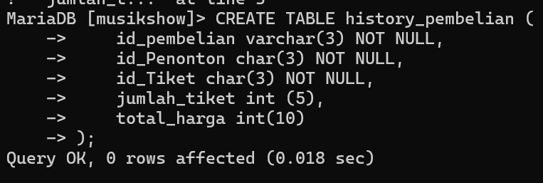

- Membuat Triger
MariaDB [musikshow]> DELIMITER $$
MariaDB [musikshow]> CREATE TRIGGER catatan_pembelian
-> BEFORE DELETE ON Pembelian
-> FOR EACH ROW
-> BEGIN
-> INSERT INTO history_pembelian (
-> id_pembelian,
-> id_Penonton,
-> id_Tiket,
-> jumlah_tiket,
-> total_harga)
-> VALUES (
-> OLD.id_pembelian,
-> OLD.id_Penonton,
-> OLD.id_Tiket,
-> OLD.jumlah_tiket,
-> OLD.total_harga);
-> END$$
Query OK, 0 rows affected (0.011 sec)

MariaDB [musikshow]> DELIMITER ;

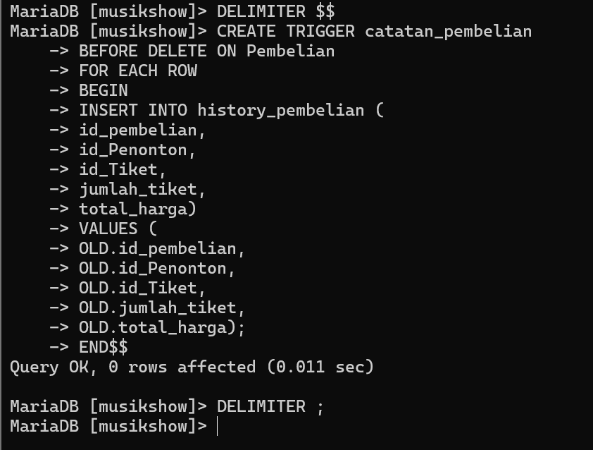

- Delete data Pembelian PM3
Menghapus
MariaDB [musikshow]> DELETE FROM Pembelian WHERE id_pembelian = 'PM3';
Query OK, 1 row affected (0.007 sec)

Membuktikan Tabel Triger History_pembelian
MariaDB [musikshow]> select * from History_pembelian;
+--------------+-------------+----------+--------------+-------------+
| id_pembelian | id_Penonton | id_Tiket | jumlah_tiket | total_harga |
+--------------+-------------+----------+--------------+-------------+
| PM3 | PN3 | TK1 | 15 | 3750000 |
+--------------+-------------+----------+--------------+-------------+
1 row in set (0.000 sec)
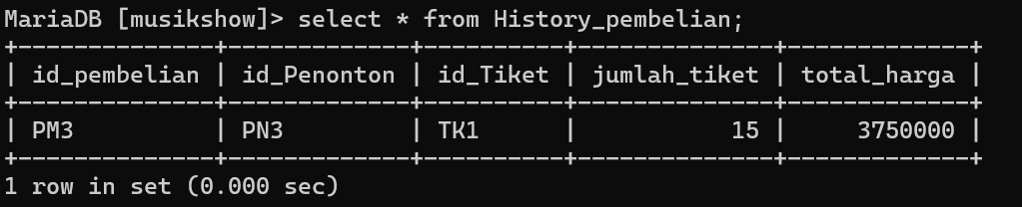

- Buat Select Join
MariaDB [musikshow]> SELECT
-> P.nama_penonton,
-> P.no_telefon,
-> PM.jumlah_tiket,
-> PM.total_harga
-> FROM
-> Penonton P
-> JOIN
-> Pembelian PM ON P.id_Penonton = PM.id_Penonton
-> JOIN
-> Tiket T ON PM.id_Tiket = T.id_Tiket
-> WHERE
-> T.jenis_Tiket = 'VIP'
-> AND
-> PM.jumlah_tiket > 15;
+---------------+------------+--------------+-------------+
| nama_penonton | no_telefon | jumlah_tiket | total_harga |
+---------------+------------+--------------+-------------+
| Almira Azaria | 2147483647 | 20 | 20000000 |
+---------------+------------+--------------+-------------+
1 row in set (0.011 sec)
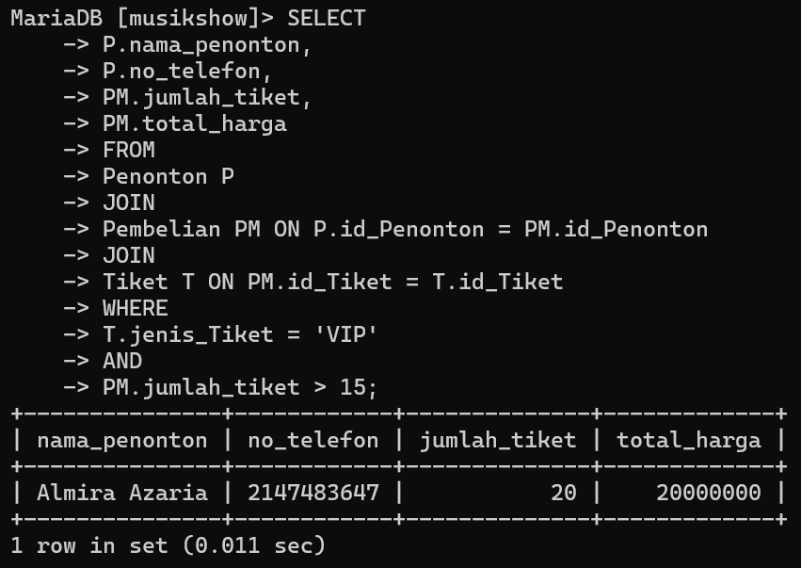

- Buat Select Join
MariaDB [musikshow]> SELECT
-> P.nama_penonton,
-> P.no_telefon,
-> T.jenis_Tiket,
-> PM.jumlah_tiket,
-> T.harga,
-> PM.total_harga
-> FROM
-> Penonton P
-> JOIN
-> Pembelian PM ON P.id_Penonton = PM.id_Penonton
-> JOIN
-> Tiket T ON PM.id_Tiket = T.id_Tiket
-> WHERE
-> PM.total_harga < 17000000;
+---------------+------------+-------------+--------------+--------+-------------+
| nama_penonton | no_telefon | jenis_Tiket | jumlah_tiket | harga | total_harga |
+---------------+------------+-------------+--------------+--------+-------------+
| Aufa Algifari | 2147483647 | Premium | 10 | 500000 | 5000000 |
+---------------+------------+-------------+--------------+--------+-------------+
1 row in set (0.000 sec)

MariaDB [musikshow]>
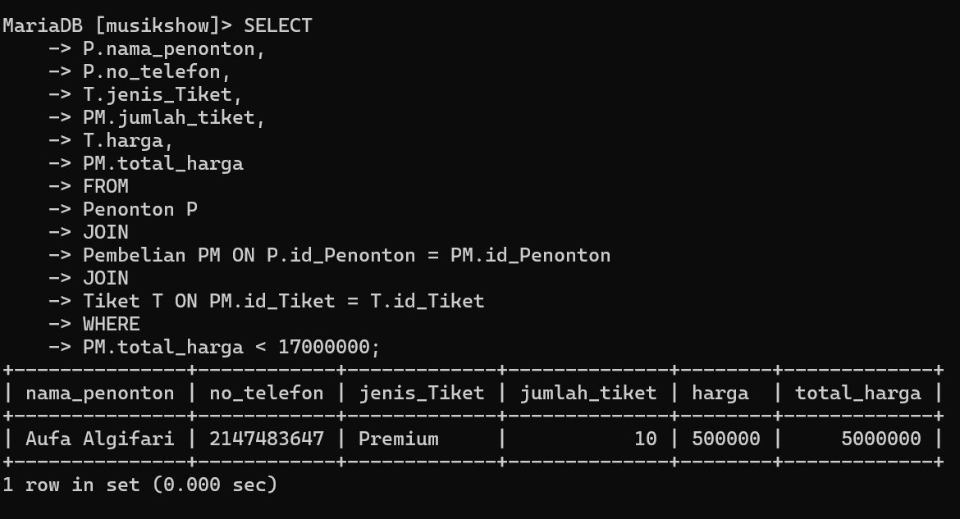

- Buat User dan Beri Akses
Buat user
MariaDB [musikshow]> CREATE USER 'admin'@'localhost' IDENTIFIED BY 'admin';
Query OK, 0 rows affected (0.006 sec)
Berikan hak akses
MariaDB [musikshow]> GRANT INSERT ON music_show.penonton TO 'admin'@'localhost';
Query OK, 0 rows affected (0.004 sec)
FLUSH
MariaDB [musikshow]> FLUSH PRIVILEGES;
Query OK, 0 rows affected (0.001 sec)
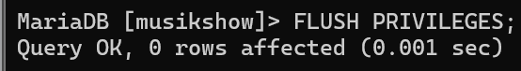

- Insert Pakai User Admin
Login
LEGION S7@LAPTOP-BJV0VQE3 c:\xampp
# mysql -u admin -p
Enter password: *****
Welcome to the MariaDB monitor. Commands end with ; or \g.
Your MariaDB connection id is 12
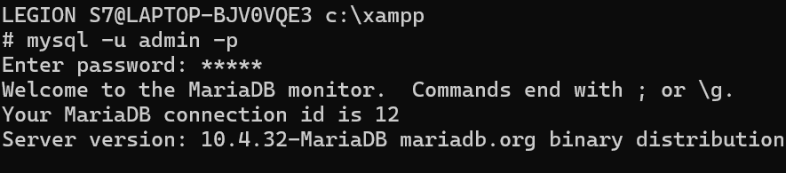

Insert
MariaDB [musikshow]> INSERT INTO Penonton (id_Penonton, nama_penonton, no_telefon) VALUES
-> ('PN4', 'Naila Alifatul', 084759086548);
Query OK, 1 row affected, 1 warning (0.006 sec)
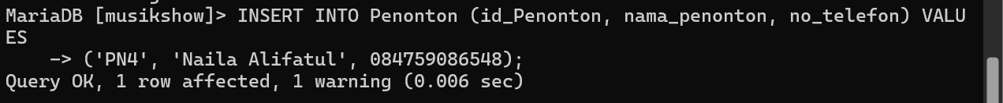

Pengecekan (Saya Pakai User Root untuk cek)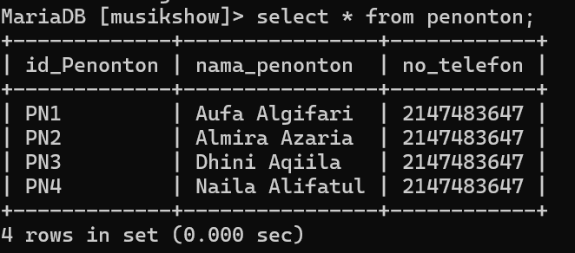

- Hapus User Admin
REVOKE
MariaDB [musikshow]> REVOKE INSERT ON musikshow.penonton FROM 'admin'@'localhost';
Query OK, 0 rows affected (0.005 sec)

FLUSH
MariaDB [musikshow]> FLUSH PRIVILEGES;
Query OK, 0 rows affected (0.000 sec)
